My responsibility is to use Django in python to connect with MySQL database and provide the result of different SQL on the website.

1. connect to database

using the Django settings modules to connect local MySQL database with PYMYSQL

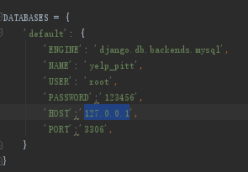

1. execute SQL

using the Django views modules to execute SQL to seek data from database

design different functions to respond to different SQL and render the result into a .html5 file

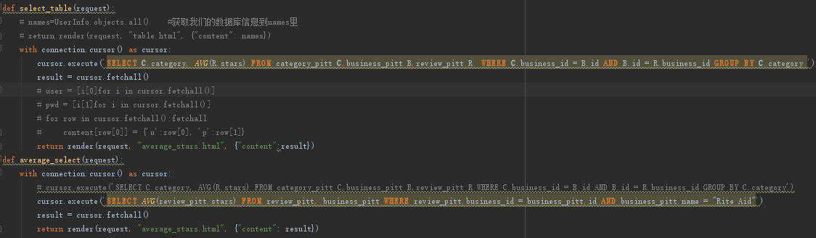

1. show the result on a webpage

using the Django urls modules to call the function and return the result on the certain webpage

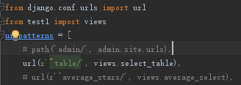

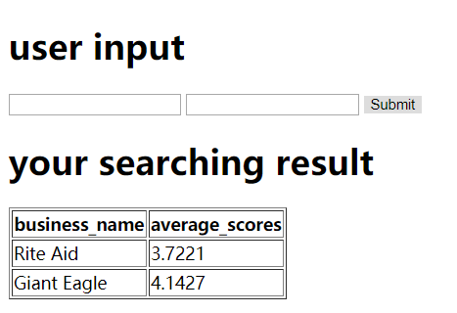

The SQL result will be shown on web depending what you input.

You can also see the result of all the categories.

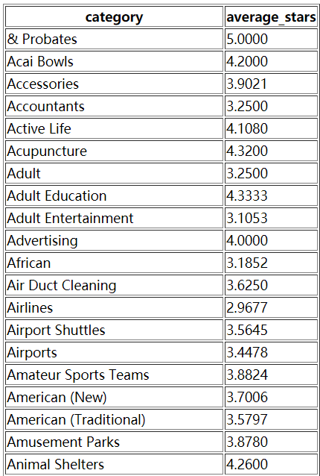

Or you want to see the bar chart of the result:

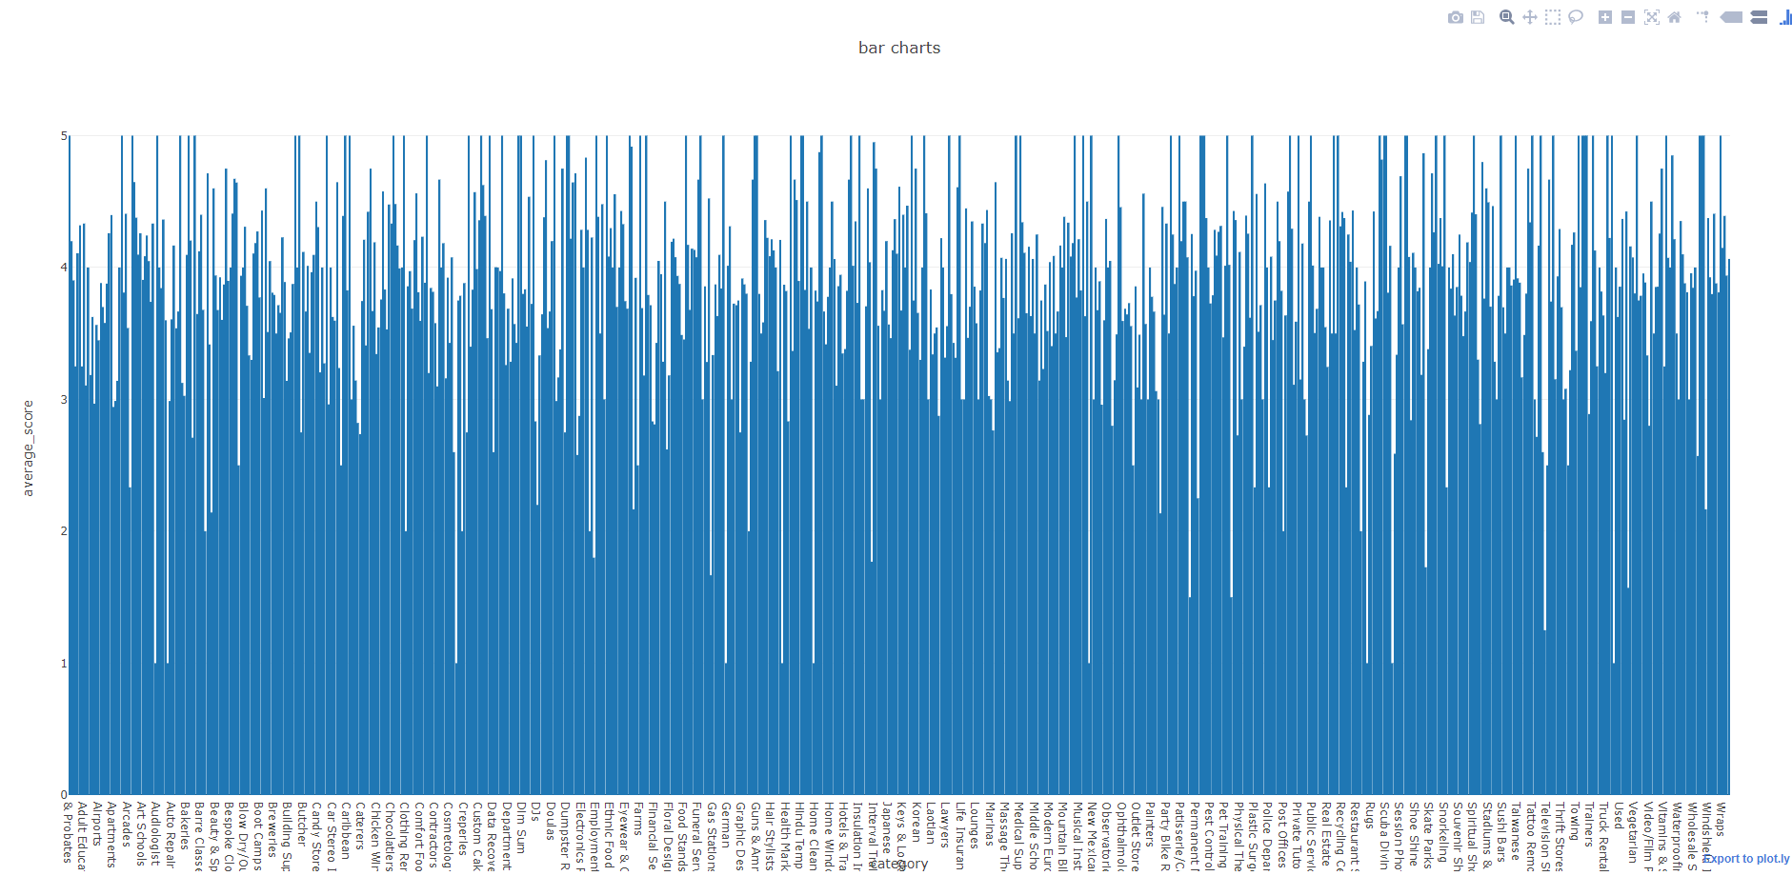

With less categories versions:

